**Ideation Phase**

**Brainstorm&Idea Prioritization Template**

|  |  |
| --- | --- |
| Date | 03 september 2022 |
| Team ID | PNT2022TMID38557 |
| Project Name | IOT based smart crop protection for agriculture |
| Maximum Marks | 4 Marks |

**Step-1: Team Gathering, Collaboration and Select the Problem Statement**

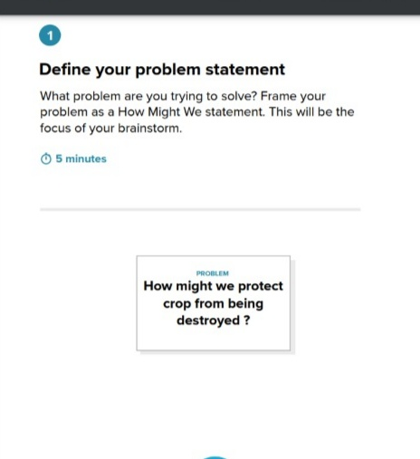

Our problem is to provide protection for crop when the farmer has unable to reach his field.

**Step-2: Brainstorm, Idea Listing and Grouping**

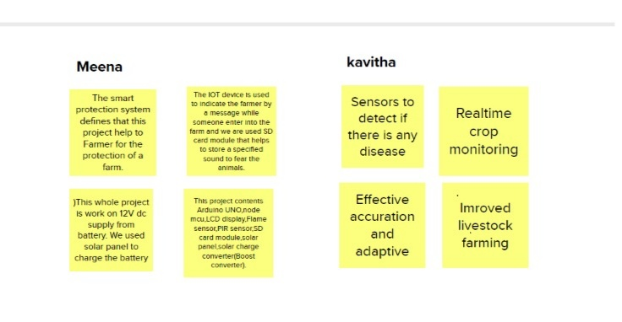

**Jayasri**

**Vinothini**

**Step-3: Idea Prioritization**

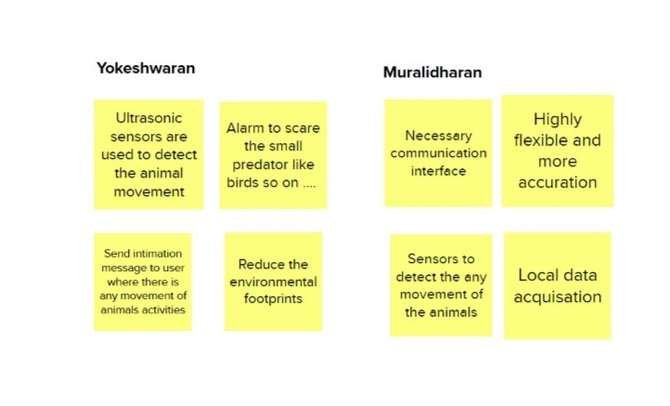

**Santhosh**

**Tamilarasan**

**GROUP IDEAS:**

